**SMART DOOR LOCKING SYSTEM USING FACE RECOGINITION**

**A REPORT**

***On***

***Inter Department Project of III B. Tech. I Semester***

By

**RAHUL CHAVALI**

[191FA07072, IT]

**VALETI VISHNU VIVEK**

[201FA07053, IT]

**JUHI KUMARI**

[201FA07075, IT]



**DEPARTMENT OF INFORMATION TECHNOLOGY**

**2022-2023**



**DECLARATION**

We hereby declare that the inter department project report entitled “SMART DOOR LOCKING SYSTEM USING FACE RECOGNITION” submitted to the Department of Information Technology, Vignan’s Foundation for Science, Technology and Research, deemed to be University. This report is the work done by us in the Department of Information Technology by collaborating with the departments “ ECE”.

**Place:GUNTUR**

**Date:22-12-2022 Signature of Students**



**CERTIFICATE**

This is to certify that the Inter Department Project Report entitled “SMART DOOR LOCKING SYSTEM USING FACE RECOGNITION” is being submitted by RAHUL CHAVALI (191FA07072),VALETI VISHNU VIVEK(201FA07053) and JUHI KUMARI(201FA07075) in partial fulfilment for the award of B. Tech Degree in Information Technology at Vignan’s Foundation for Science, Technology and Research, deemed to be University It is a record of bonafide work carried out by them in Department of Information Technology, Vignan’s Foundation for Science Technology and Research under the supervision of “DR.Ramakrishnan R and Mr.P.Ramdoss”.

**Signature of Project Guide Signature of HOD**



**Acknowledgements**

Inter department project is an opportunity to work collaboratively with other departments such as ECE, EEE, Automobile, Bio Technology, Food Technology etc., students and helps in gaining knowledge in other department domains.

We express our gratitude towards the Management for providing opportunity to work and implement inter department projects.

We feel it our responsibility to thank “DR.Ramakrishnan R and Mr.P.Ramdoss” under whose valuable guidance that the project came out successfully after each stage. It is a great pleasure for us to express our sincere thanks to Prof. K. V. Krishna Kishore, HOD, IT of VFSTR Deemed to be University, for providing me an opportunity to do Inter department projects.

We extend our wholehearted gratitude to all our faculty members of Department of Information

Technology who helped us in our academics throughout course.

Finally, we wish to express thanks to our family members for the love and affection overseas and forbearance and cheerful depositions, which are vital for sustaining effort, required for completing this work.

With Sincere regards,

RAHUL CHAVALI(191FA07072)

VALETI VISHNU VIVEK(201FA07053)

JUHI KUMARI(201FA07075)

**CONTENTS**

|  |  |  |
| --- | --- | --- |
| **S.NO.** | **DESCRIPTION** | **PAGE NO.** |
| **1.** | ABSTRACT | **6** |
| **2.** | PROBLEM STATEMENT | **7** |
| **3.** | INTRODUCTION | **8** |
| **4.** | SYSTEM ENVIRONMENT | **9** |
| **5.** | ANALYSIS | **10** |
| **6.** | DESIGN | **18** |
| **7.** | IMPLEMENTATION | **22** |
| **8.** | RESULT | **28** |
| **9.** | TESTING | **33** |
| **10.** | CONCLUSION | **34** |

**1.ABSTRACT**

In this system we have proposed face recognition door lock system using Arduino for security purpose. Implementation of the system is for monitoring whether any unknown person is entering in to the door. We have established communication with electronic devices through face detection with the help of ESP-32 camera Arduino platform. As soon as the person enters near the door, ESP-32 camera captures the image and face detection process is done then if it matches with database images then the door is unlocked otherwise a message with the picture of a person will be sent to the registered mobile.

2.**PROBLEM STATEMENT**

* Implement the Door Locking System using face recognition

**3.INTRODUCTION**

Nowadays, as the technology is increasing, facilities for human beings are increasing. In day-to-day activities, life of people has become very easier with the incorporation of many technologies. On the other hand, it also creates security issues. The traditional door locks have a problem that almost anyone can break and enter into your house. Hence it is a great challenge to overcome these problems. In general, in order to secure home, people make use of CCTV. Images will store in the database, so that the action can be taken when any suspicious incident happens.

A main function of door is to preserve privacy and it is also the first security barrier to secure a room or area. With the numbers of crimes increasing every day, several door lock systems have been developed to allow a person to access the door. The use of IoT technology to door lock able to increase the security level of the system which this technology allows a user to monitor and control the security system via mobile. Thus, this project is suitable to implement in the office environment and to bring conveniences to themselves.

**4.SYSTEM ENVIRONMENT**

**SOFTWARE REQUIREMENTS:**

Operating System : Windows

Web Technologies :Embedded C

Database : Firebase Database

IDE :Arduino

**HARDWARE REQUIREMENTS**

* 1. TTL Programmer
  2. Relay Module
  3. LED
  4. Solenoid Lock
  5. Jumper Wires
  6. ESP32-CAM
  7. 12 V Battery
  8. Regulator
  9. Capacitor

10. Breadboard

**5.ANALYSIS**

**EXISTING SYSTEM:**

For the most part, customary locks are substantial and that are not solid as they can harm basically by utilizing a few apparatuses. With these kinds of locks there is no security. Some of the door locking system is also existed but it does not deal with more security. And also it is not more flexible.

**PROPOSED SYSTEM:**

The main objective of this project is to enhance the security of the door locking system. In our proposed system we are going to use ESP32-CAM which is used take some pictures of the users and store those pictures in database. when the user face is recognized, it will automatically open the lock. If some unauthorized person tries to unlock the door it will send the message to registered mobile number.

**ARDUINO IDE:**

The Arduino Integrated Development Environment - or Arduino Software (IDE) - contains a text editor for writing code, a message area, a text console, a toolbar with buttons for common functions and a series of menus. It connects to the Arduino hardware to upload programs and communicate with them.

Programs written using Arduino Software (IDE) are called **sketches**. These sketches are written in the text editor and are saved with the file extension. ino. The editor has features for cutting/pasting and for searching/replacing text. The message area gives feedback while saving and exporting and also displays errors. The console displays text output by the Arduino Software (IDE), including complete error messages and other information. The bottom righthand corner of the window displays the configured board and serial port. The toolbar buttons allow you to verify and upload programs, create, open, and save sketches, and open the serial monitor.

**FIREBASE DATABASE:**

The Firebase Realtime Database is a cloud-hosted database. Data is stored as JSON and synchronized in Realtime to every connected client. When you build cross-platform apps with our Apple platforms, Android, and JavaScript SDKs, all of your clients share one Realtime Database instance and automatically receive updates with the newest data.

**TTL PROGRAMMER:**

A TTL Signal is a kind of hardware interface standard based on the electrical properties of TTL (Transistor-Transistor Logic).

The USB to TTL converter solves this problem by providing a serial port connection between a host computer and a development board, with the correct interfaces and signal levels for each.

**RELAY MODULE:**

A power relay module is an electrical switch that is operated by an electromagnet. The electromagnet is activated by a separate low-power signal from a micro controller. When activated, the electromagnet pulls to either open or close an electrical circuit.

**SOLENOID LOCK:**

A solenoid lock works on the electronic-mechanical locking mechanism. This type of lock has a slug with a slanted cut and a good mounting bracket. When the power is applied, DC creates a magnetic field that moves the slug inside and keeps the door in the unlocked position. The slug will retain its position until the power is removed. When the power is disconnected, the slug moves outside and locks the door. It doesn’t use any power in a locked state. To drive the solenoid lock, you would need a power source that can give 12V @ 500mA.

**ESP32-CAM:**

ESP32-CAM is a low-cost ESP32-based development board with onboard camera, small in size. It is an ideal solution for IoT application, prototypes constructions and DIY projects. The board integrates WIFI, traditional Bluetooth and low power BLE , with 2 high-performance 32-bit LX6 CPUs. It adopts 7-stage pipeline architecture, on-chip sensor, Hall sensor, temperature sensor and so on, and its main frequency adjustment ranges from 80MHz to 240MHz.

**WORKING PROCESS:**

This part covered the essential settings including the ESP32 Camera board manager installation. The system is powered by ESP 32 CAM circuit. The Circuit Diagram for ESP32-CAM Faces Recognition Door Lock System is combined with an TTL Programmer, Relay Module, and Solenoid Lock. The UNO board is employed to flash the code into ESP32-CAM while the relay module is employed to modify the Solenoid lock on or off. Here Arduino IDE is employed to program ESP32-CAM.

**CIRCUIT CONNECTION EXPLANATION:**

Male Headers are connected with the Power Supply and I/O pins of the ESP32 Camera Module. The SV3 and SV4 male headers are used to make connection with the bottom circuit board. The JP1 and JP2 male headers are used to connect 3.3V and 5v Lipo Battery. While all the other male headers are used for interfacing Sensors and other output devices.

The 5V regulated power supply and the headers connections with the ESP32 Camera module remains the same. This time We added a one channel relay module which is used to control the electronic lock. The One Channel relay module is controlled using the IO Pin 12 of the ESP32 Camera module. The onboard white LED is connected with the IO4.

Using these top and bottom circuit boards, we can easily connect different types of IO devices and can monitor and control different electronic sensors and output devices without any problem. As in this tutorial is about the door lock control system and for this we will need an electronic lock that we can control through electrical signals.

A 12V Electronic Lock provided with two Red and Black wires. Red is the 12V wire and of course Black is the ground wire. When these wires of the Electronic Lock are connected with the 12Vdc power supply the Electronic Lock will get open. We have soldered a female type power jack.

If we don’t cut this wire and connect the 12Vdc power supply the Electronic Lock will remain Open forever until you disconnect the 12V power supply. For the automatic control of the Electronic Lock we need to cut one of the two wires. So we selected the Red wire and cut it. Now if you connect the 12Vdc power supply with the DC Female Power jack and you touch the two heads of the Red wire, the Electronic Lock open and if you disconnect the two heads of the red wire the Electronic Lock will close again. So by connecting and disconnecting the red wires we can control the Electronic Lock. Instead, of manual connecting and disconnecting these red wires, we will use a relay.

We soldered the 12V and GND wires from the relay module with the 12V and Ground points of the power supply and connected the relay module input wire with the IO12 of the ESP32 Camera module.

We completed our connections .

**Before uploading the code to ESP32CAM**, **do the following setting**:

* Update the**Preferences** –> Additional boards Manager URLs: https://dl.espressif.com/dl/package_esp32_index.json, http://arduino.esp8266.com/stable/package_esp8266com_index.json
* **Board Settings:**
  + Board: “ESP32 Wrover Module”
  + Upload Speed: “921600”
  + Flash Frequency: “80MHz”
  + Flash Mode: “QIO”
  + Partition Scheme: “Hue APP (3MB No OTA/1MB SPIFFS)”
  + Core Debug Level: “None”
* COM Port: Depends on Your System
* GPIO 0 must be connected to GND pin while uploading the sketch
* After connecting GPIO 0 to GND pin, press the ESP32 CAM on-board RESET button to put the board in flashing mode

**How to get the IP from ESP32CAM:**

1. After uploading the code disconnect GPIO 0 from GND pin.  
2. Open Serial Monitor with Baud rate 115200.  
3. Press the RESET button on the ESP32CAM board  
4. Copy the IP Address from the last line.

Now connect all the components as per the circuit diagram. And give the 12v DC supply to circuit.

After that open any browser, then type the IP address to start the stream.  
Now, we have to enrol faces.

1) Click on the Start Stream.  
2) Turn on Face Detection and Face Recognition.  
3) Click on Enrol Face.  
4) Then ESP32CAM will take some sample pictures of the face.  
5) At last, a green box will appear around the face.

In this way we can enrol multiple faces.

**6.DESIGN**

**Flow chart of the proposed system:**

Capture face using camera and open CV with camera

Face detection

If face detected in built in databse

Notify owner with message

Open Door and send notification

**Flow chart of the source code:**

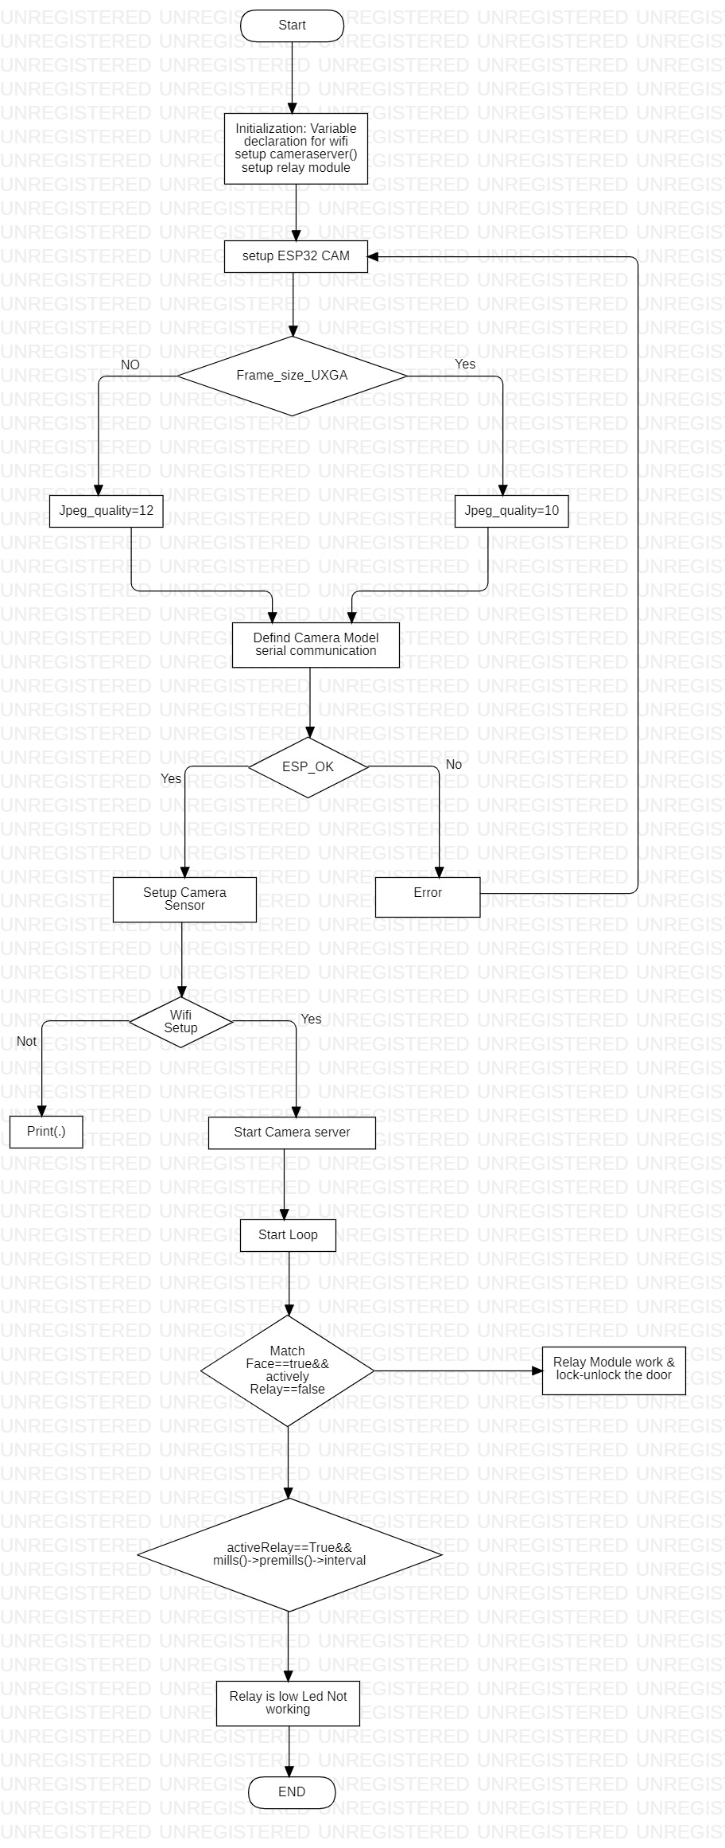

**Block Diagram:**

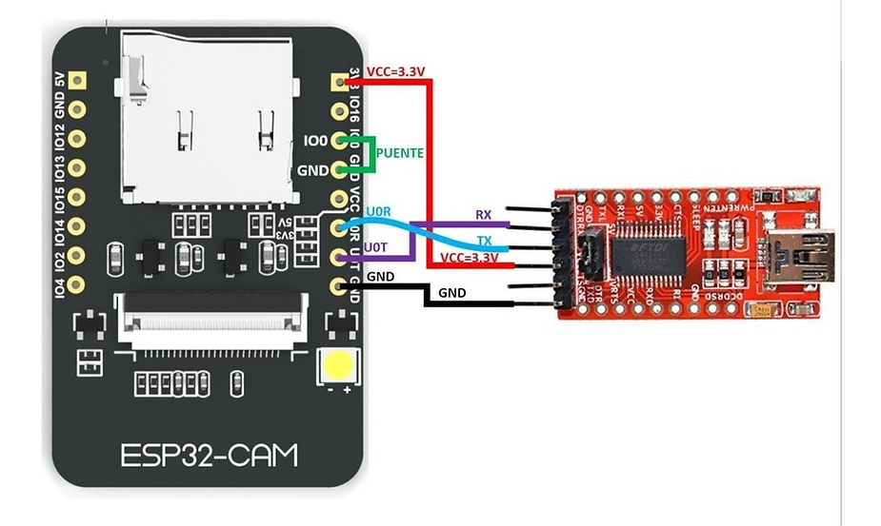

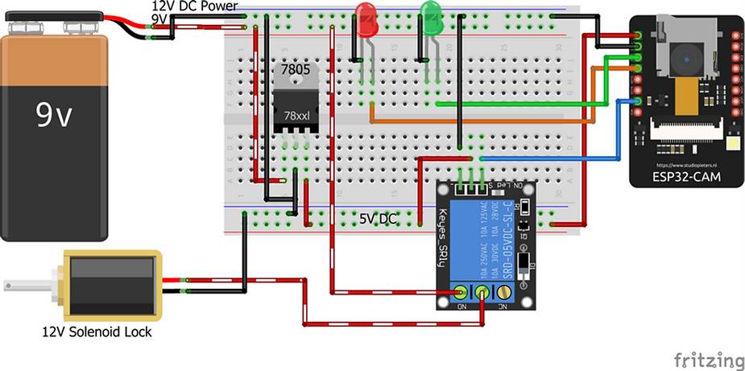

**7.IMPLEMENTATION**

**Source code:**

#include "esp_camera.h"

#include <WiFi.h>

//

// WARNING!!! Make sure that you have either selected ESP32 Wrover Module,

// or another board which has PSRAM enabled

//

// Select camera model

//#define CAMERA_MODEL_WROVER_KIT

//#define CAMERA_MODEL_ESP_EYE

//#define CAMERA_MODEL_M5STACK_PSRAM

//#define CAMERA_MODEL_M5STACK_WIDE

#define CAMERA_MODEL_AI_THINKER

#define Relay 2

#define Red 13

#define Green 12

#include "camera_pins.h"

const char* ssid = "vivek"; //Wifi Name SSID

const char* password = "7053"; //WIFI Password

void startCameraServer();

boolean matchFace = false;

boolean activateRelay = false;

long prevMillis=0;

int interval = 5000;

void setup() {

pinMode(Relay,OUTPUT);

pinMode(Red,OUTPUT);

pinMode(Green,OUTPUT);

digitalWrite(Relay,LOW);

digitalWrite(Red,HIGH);

digitalWrite(Green,LOW);

Serial.begin(115200);

Serial.setDebugOutput(true);

Serial.println();

camera_config_t config;

config.ledc_channel = LEDC_CHANNEL_0;

config.ledc_timer = LEDC_TIMER_0;

config.pin_d0 = Y2_GPIO_NUM;

config.pin_d1 = Y3_GPIO_NUM;

config.pin_d2 = Y4_GPIO_NUM;

config.pin_d3 = Y5_GPIO_NUM;

config.pin_d4 = Y6_GPIO_NUM;

config.pin_d5 = Y7_GPIO_NUM;

config.pin_d6 = Y8_GPIO_NUM;

config.pin_d7 = Y9_GPIO_NUM;

config.pin_xclk = XCLK_GPIO_NUM;

config.pin_pclk = PCLK_GPIO_NUM;

config.pin_vsync = VSYNC_GPIO_NUM;

config.pin_href = HREF_GPIO_NUM;

config.pin_sscb_sda = SIOD_GPIO_NUM;

config.pin_sscb_scl = SIOC_GPIO_NUM;

config.pin_pwdn = PWDN_GPIO_NUM;

config.pin_reset = RESET_GPIO_NUM;

config.xclk_freq_hz = 20000000;

config.pixel_format = PIXFORMAT_JPEG;

//init with high specs to pre-allocate larger buffers

if(psramFound()){

config.frame_size = FRAMESIZE_UXGA;

config.jpeg_quality = 10;

config.fb_count = 2;

} else {

config.frame_size = FRAMESIZE_SVGA;

config.jpeg_quality = 12;

config.fb_count = 1;

}

#if defined(CAMERA_MODEL_ESP_EYE)

pinMode(13, INPUT_PULLUP);

pinMode(14, INPUT_PULLUP);

#endif

// camera init

esp_err_t err = esp_camera_init(&config);

if (err != ESP_OK) {

Serial.printf("Camera init failed with error 0x%x", err);

return;

}

sensor_t * s = esp_camera_sensor_get();

//initial sensors are flipped vertically and colors are a bit saturated

if (s->id.PID == OV3660_PID) {

s->set_vflip(s, 1);//flip it back

s->set_brightness(s, 1);//up the blightness just a bit

s->set_saturation(s, -2);//lower the saturation

}

//drop down frame size for higher initial frame rate

s->set_framesize(s, FRAMESIZE_QVGA);

#if defined(CAMERA_MODEL_M5STACK_WIDE)

s->set_vflip(s, 1);

s->set_hmirror(s, 1);

#endif

WiFi.begin(ssid, password);

while (WiFi.status() != WL_CONNECTED) {

delay(500);

Serial.print(".");

}

Serial.println("");

Serial.println("WiFi connected");

startCameraServer();

Serial.print("Camera Ready! Use 'http://");

Serial.print(WiFi.localIP());

Serial.println("' to connect");

}

void loop() {

if(matchFace==true && activateRelay==false)

{

activateRelay=true;

digitalWrite(Relay,HIGH);

digitalWrite(Green,HIGH);

digitalWrite(Red,LOW);

prevMillis=millis();

}

if (activateRelay == true && millis()-prevMillis > interval)

{

activateRelay=false;

matchFace=false;

digitalWrite(Relay,LOW);

digitalWrite(Green,LOW);

digitalWrite(Red,HIGH);

}

}

**8.RESULT**

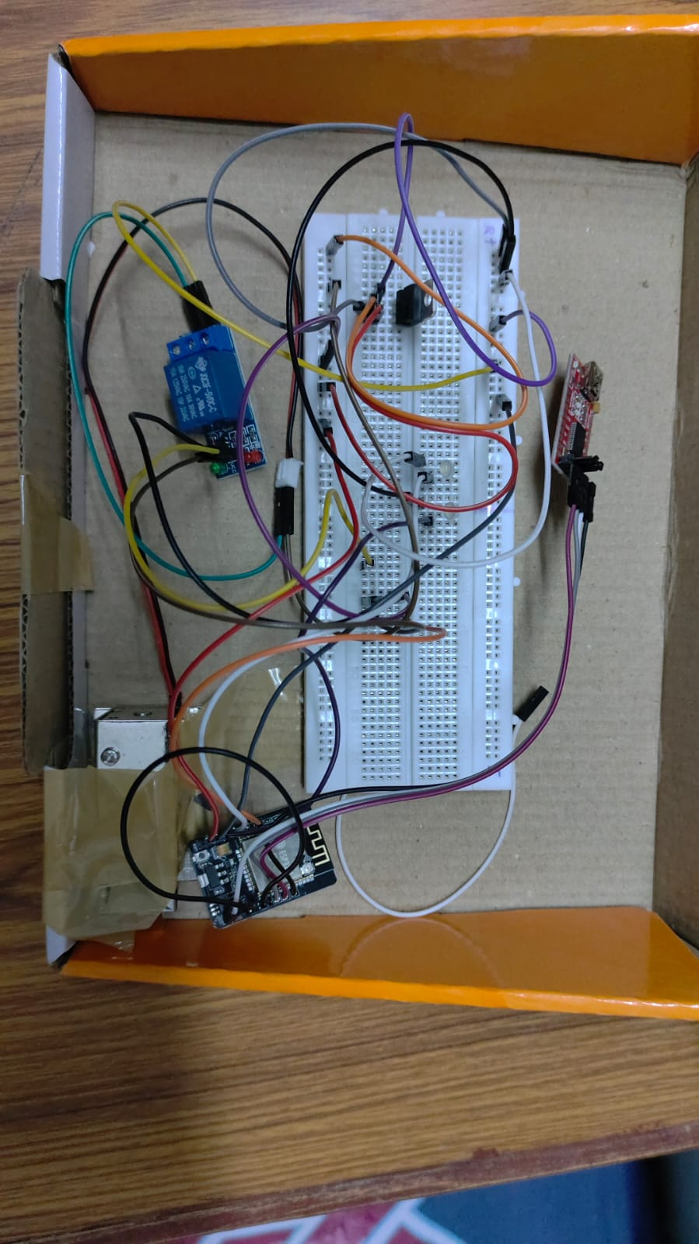

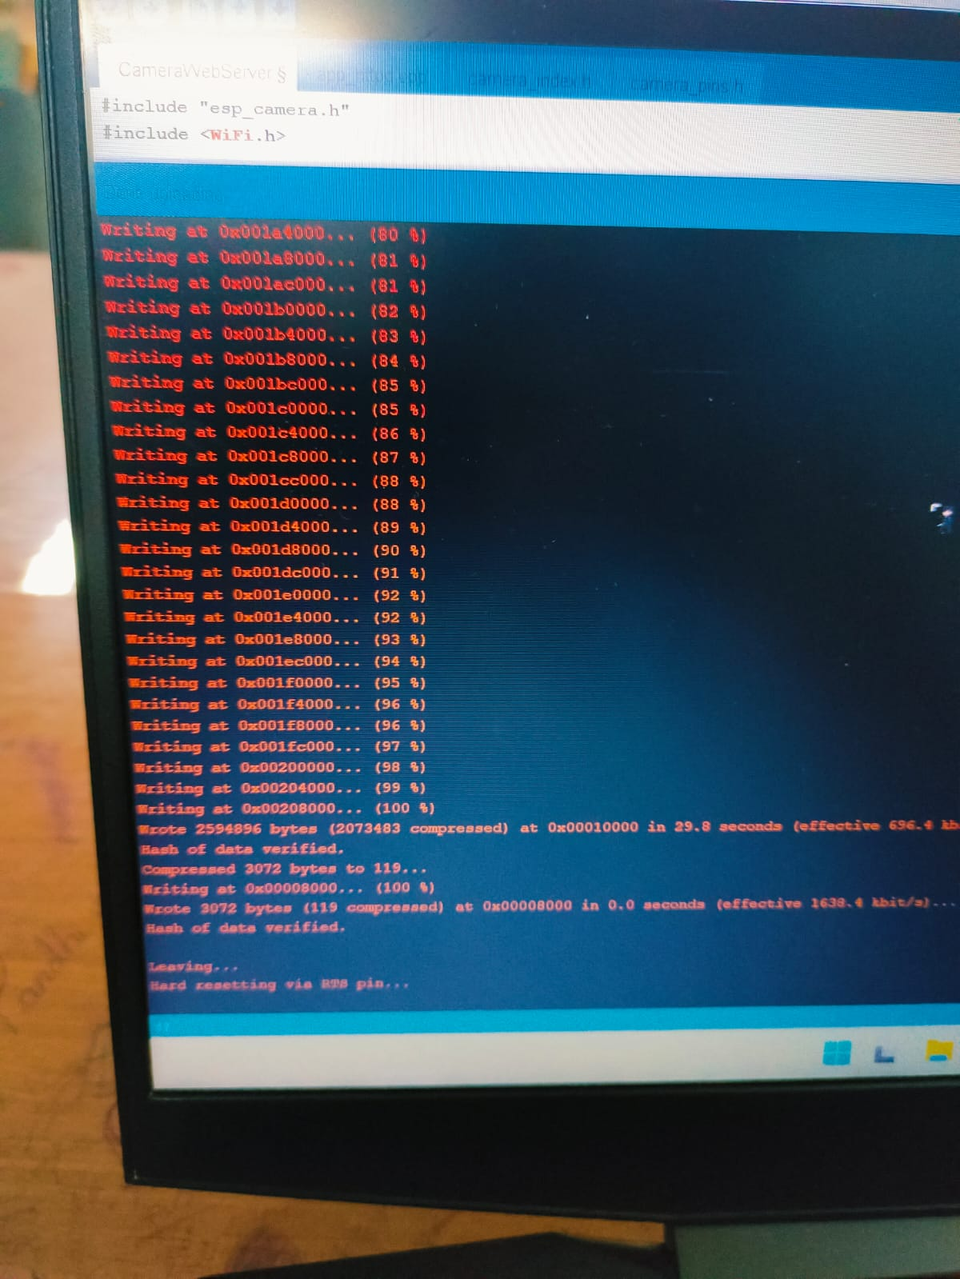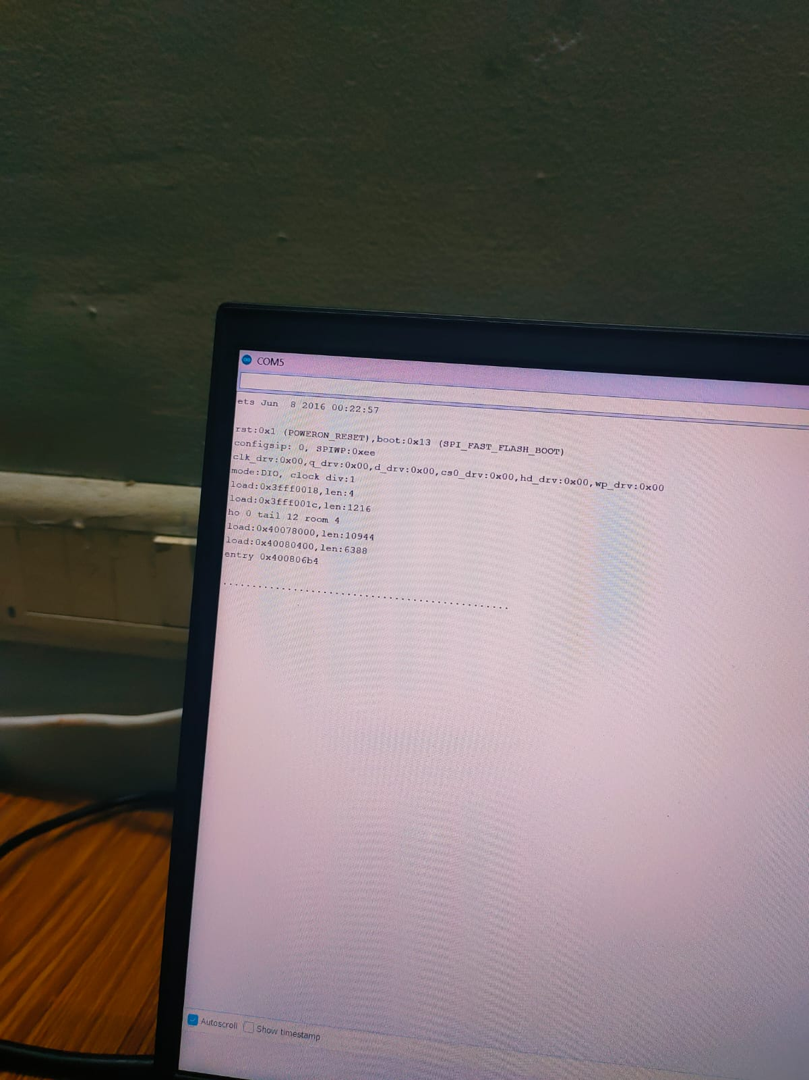

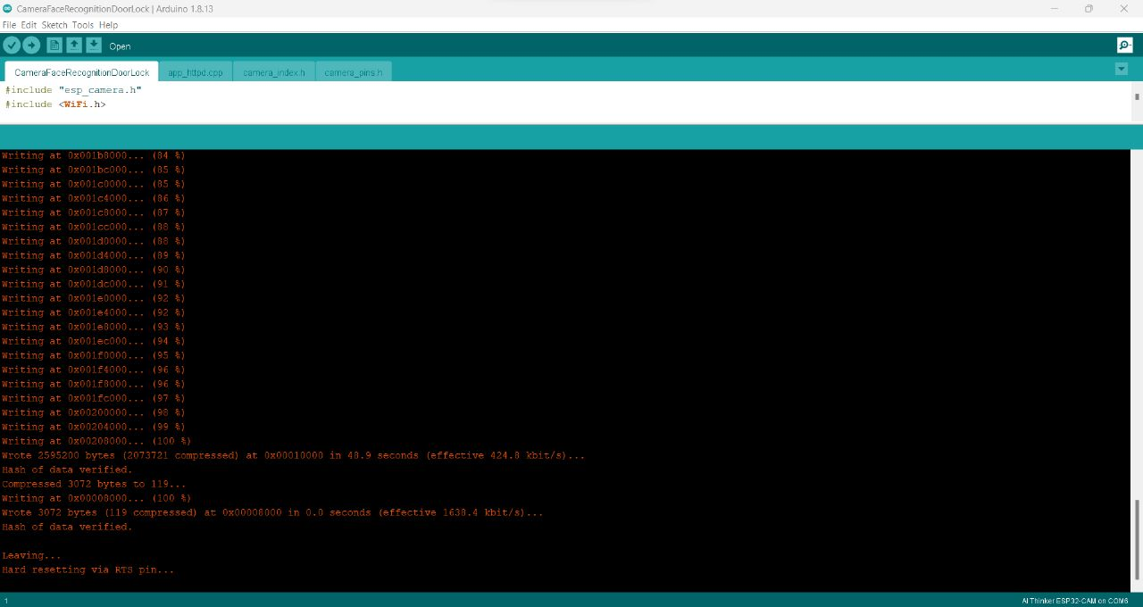

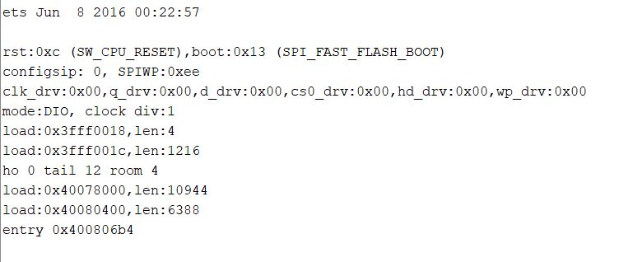

**9.TESTING**

**STEP1:-**

We started off by powering up the Electronic Lock and the ESP32 Camera Module using a 12V adaptor. You will need the local IP address for the live video streaming using the same WIFI network.

**STEP2:-**

So, We know about our local IP address. Turn ON the Face Detection and Face Recognition and click on the start stream button. Click on the Enroll face and start taking the samples, when everything is done successfully the electronic lock will open and also the white LED will turn ON.

**STEP3:-**

As you can see, everything is done successfully, if you find it hard to follow the steps, watch video tutorial, given in the end of this article.

You can see the text welcome on the recognized face. You can change this text; you can write the person’s name or you can write anything. For this you will need to open the app_httpd.cpp file. If you scroll down, you will see the welcome text, you can change this, you can also see the intruder Alert! Text, this is for the unauthorized person, you can also change this text.

**10.CONCLUSION**

There are several other features those will be integrated in the future aiming to solve many problems and advancements. The features to be integrated in future is an impact detection sensor, which is capable of detecting any kind of physical impact made on the door and raising an alarm on the admin’s mobile device. Users can add new doors or remove them accordingly. It eliminates the hassle of carrying several keys and more importantly the problems of losing keys. In this system we have implemented a face recognition door lock system. Recognizing of faces is done by using cascade classifiers, which gets a high accuracy and will store in the database. For this testing, we have used 5 images only. Computer vision is used in the IOT. For security purpose, we have implemented real time face detection by Haar classifier. Thus, this system can useful for senior citizens living alone and for immobilized people. Hence the proposed system is practically easy to construct and easy to track the path.